**Introduction:**

Our project is such an online service platform for all urban home and office services. Here we will try to help customers to hire expert service providers and to get things done without any hassle.

It will give the opportunity to select your required service from our available household services where customers can hire one of our expert and verified professionals.Once the service is booked a verified service provider will be sent to customer’s premises at their scheduled time. After the service, customers will be able to pay securely and easily through the app as well as on cash payment process.

**Motivation: ,,,Now i’m going to say thatso why we motivated to implement this**

Online platforms intermediate information and communication flows on the internet.One of the benefits of online service marketplace is that it's easy to scale the business quickly.

There are a lot of people in our society who may or may not be educated but they might be experienced on different categories of work.For instance, people who are expert in appliance repairing or have experience to work as electrician or people who do the car care services,plumbing, gadgets repairing etc. usually don’t have any exact place of work. Therefore, they need to search for work almost everyday.An online service like us can make it more easier for these people to find a suitable job for them in their experienced field. Moreover, our website can save peoples’ time as usually people need to search for service providers to know if they are available or not.

**Importance:** In an online service marketplace like us, it will be easier for the people who are expert in appliance repairing or have experience to work as electrician or some do the car care services,plumbing, gadgets repairing and so on to find their source of work.Here customers will get multiple household services at one place which will blend technology with daily life services.In this Covid-19 situation,such online service marketplace will be very helpful for the people to find service providers.Apart from ensuring efficient supply and providing service warranty ,it will also help customers to hire verified and professional service providers which will ensure our service quality.

**Git-Link:** [**https://github.com/Shawan-Das/ServiceEasy-Dot-Com**](https://github.com/Shawan-Das/ServiceEasy-Dot-Com)

**Previous works & their Limitations**

In terms of developing our website, we have found some existing works like us but they have some limitations. For instance here some previous works and their limitations are defined :

**Previous similar works:**

**Sheba xyz:**



It is an online platform that connects the users to the on-demand specialized and verified service providers on various home services such as Electricians, Plumbers, Beauticians, Carpenters, Pest Control, Home Cleaning, Home & Office Shifting, etc. Any users can avail their services through their app which is available on both Google Play Store and Apple App Store along with the website.

**Alpha pack & shift**



It is a branding resettle company. They have one-stop house shifting service. That is, all the services under one roof. For example: all packing material including cartoon box for packing, transport: truck pickup covered van is everything they propose. Their labors are not hired.

**CleaningBd:**



It is a pest control service website which offers the highest professionalism in commercial cleaning services for office space. diplomatic missions, shops, shopping complex etc.

**Limitations:**

Websites like “Sheba.xyz” doesn’t give customers the opportunity to choose the service providers. While selecting providers they send according to their own choice rather than giving customers any option to choose them. Websites like” Alpha pack & shift”, “CleaningBD” only provide one sector service. Maximum online service websites require payment first method. Maximum online services use a middle party to manage interaction between the service providers and customers.

**Design:**

**ER Diagram Of our Project**

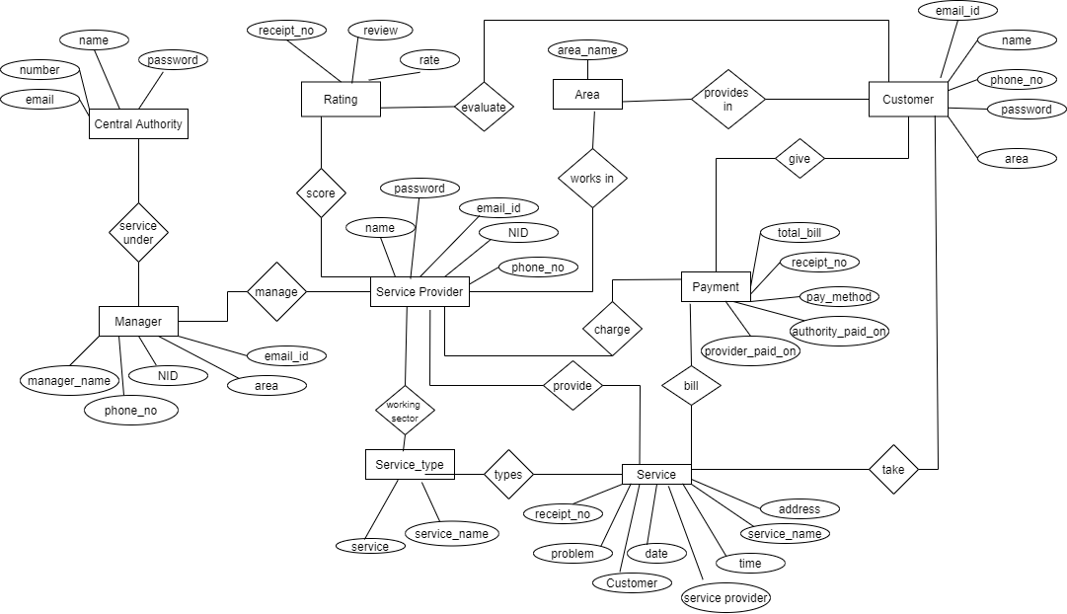

There are 9 entities Central Authority, Customer, Service Provider, Manager, Service_type, Service, Area, Rating and Payment. There are many to many relations between the entities. The relation between Central Authority and Manager is ‘Service Under’, Manager and Service

Provider is ‘Manage’, Service Provider and Service is ‘Provide’ and so on. The relations are given in the diamond shape signs.

**Modern Tools Used:**

**1.Visual Studio Code 5.Javascript**

**2.HTML 6.Bootstrap**

**3.CSS 7.Payment Gateway**

**4.Django 8.Sms Gateway**

**User Manual:**

People can view the available services, pages like contact us & about us, book information and the other information of the homepage. To use our website or to order, people need to register first. If anyone has a previous account they need to login and then they can order from their profile.

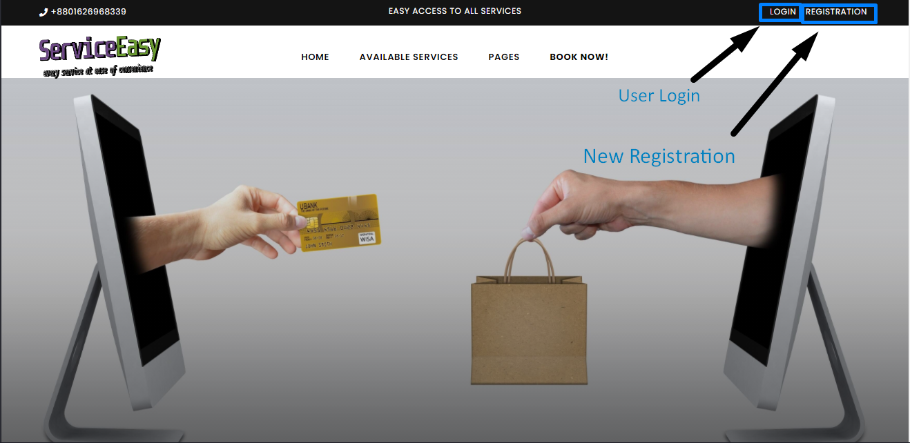

If people don’t have an account they need to register themselves first. When they select the registration option,they will go to the registration page for registration. They have to provide their name, email address, password,mobile number and then click to create. Then an user

account will be created for the user.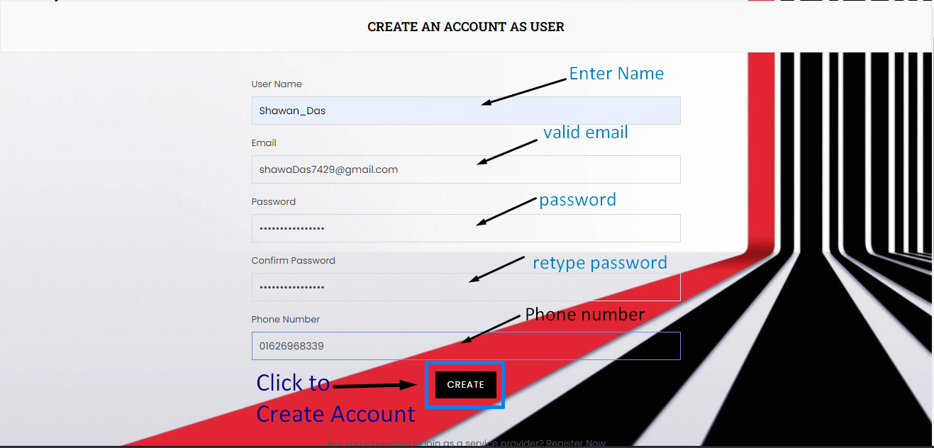

After doing the registration, they will come back to the login page and complete the login process. After login, user can see their profile. If anyone has a previous account, they can select the login option from the home page and that will also take them to the login page. They need to put their email address and password for the login process. The login information will be verified using the backend codes. If the information is correct then the user will go to our after login homepage and if their information doesn’t match with the verification, they will get a message that their email or password is incorrect. People can also select the registration option from below if they don’t have any account yet.

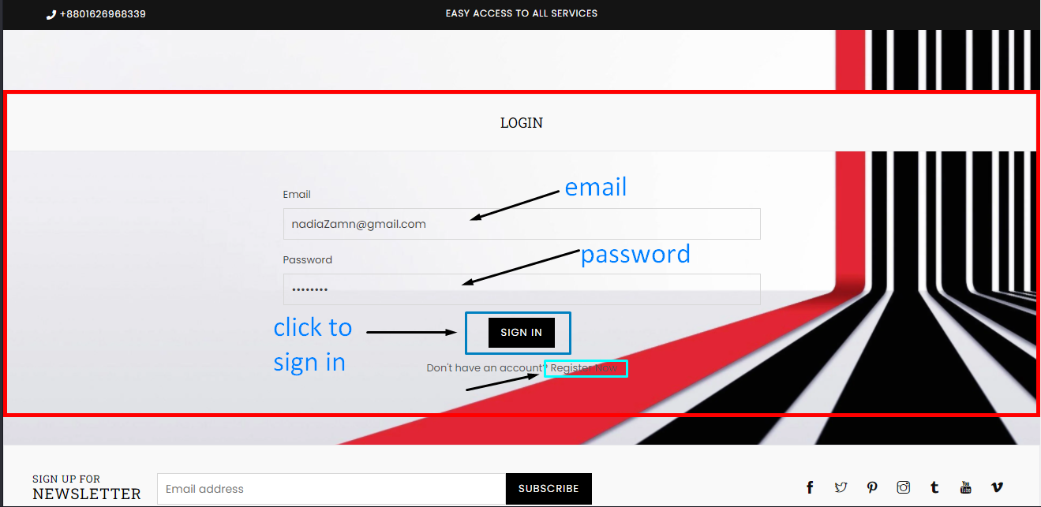

After the login, user will see the after login homepage. This is the same as the previous homepage, but there will be an option to go to their user profile. They can order their required service using the ‘BOOK NOW!’ option.

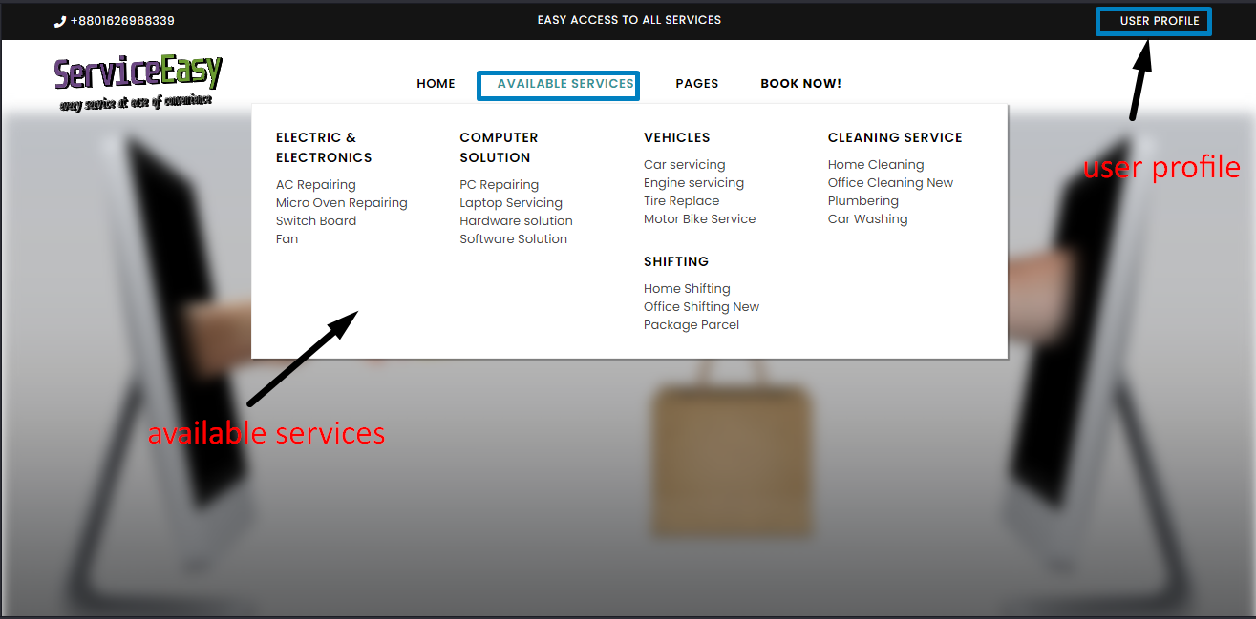

In the user profile, here personal information of users will be displayed.(user’s name, email id,phone number).Besides that there will be”bill history ” option where user can check their bill history of their ordered services.Then there will be a “ Log out “ button.By clicking this,user can log out from their account and after that they will be redirected to our home page and if they want to book any services they need to log in again.

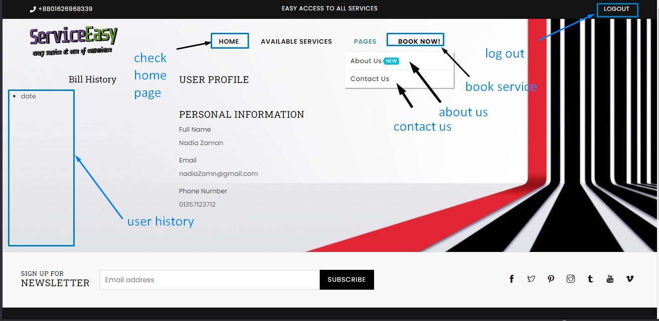

When the user selects the booking option they will be sent to the order booking page. There they can select the category of the service they want. After that they have to give a short description about the problem they are facing. They can select the timing schedule when they want to take the service, select their area and at last they have to click on the ‘BOOK NOW!’ option to confirm the order. Our initial charge is also given on this page.

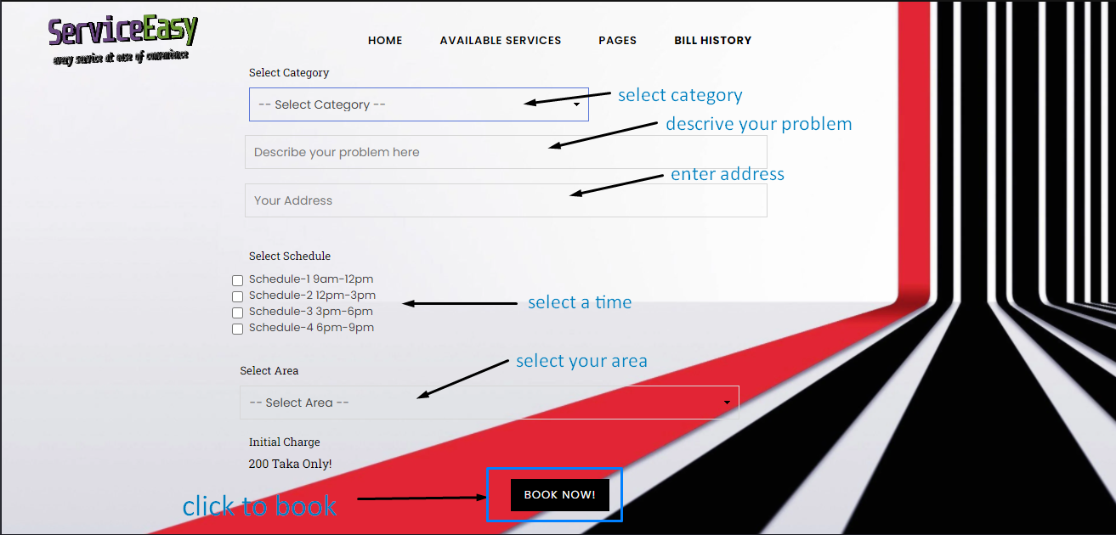

**Conclusion:**

**Things we have learned from this project:**

After completing this project, we have also learnt to design and use database. We learned to implement database in Django. Now we can create templates using bootstrap, javascript and CSS. Finally we have learned to use Django where we have learnt to connect HTML with Django. We have also learnt how to do planning for developing a system and also learnt to communicate with team members regarding project works. Using all these leanings now we know how to build an e-commerce system.

**Difficulties that we have encountered during the project work:**

Since this is our first project implementation using Django, we have faced some difficulties while creating the website. For the website pages we have used templates and we faced difficulties to design the templates according to our project design. We had to learn and search for a lot of information to edit and change the design of the templates. We also faced a problem in Javascript. Moreover, there were a lot of errors in Django and we didn’t find enough resources for Django. We weren’t familiar with the error we were facing and so it took a lot of time to solve those errors. We faced difficulties while finding resources to build an e-commerce website because there weren't enough resources available for this. Though we have faced several problems while building the website, we have learned many things from the project which we will be very beneficial for our future.

**Future direction:**

In future, we will try to expand our website widely. For instance: we have planned to add more service providers into our website. We will also add more services so that customers can get more services from us.We are also thinking about registering our service providers through online.We will also add rating features in future where customers can give their review to the service providers on the basis of their given service.We will also display service provider’s “Profile” to customers where they can check providers’ ratings on previous works.

**Reference:**

**Appendix A(CEP Mapping)**

How Ks are addressed through the project and mapping among Ks, COs, and POs

| **Ks** | **Attribute** | **How Ks are addressed through the project** | **COs** | **POs** |
| --- | --- | --- | --- | --- |
| K1 | **Science:** theory-based understanding of the natural science applicable to the discipline. | We have to ensure that only trusted and verified people can provide services so that customers can get better services. Also we have ensured proper security of users. | CO1 | Engineering  Knowledge |
| K3 | **Eng. Fundamentals:** a systematic, theory-based formulation of engineering fundamentals required in the engineering discipline. | To provide better services, we tried to add trustworthy professional service providers. Customers can review the services. They can also contact us if they face any kind of problems. | CO1 | Engineering  Knowledge |
| K5 | **Eng. Design:**  Knowledge that supports engineering design in a practical area. | To implement this project, we had to design a database, the relation between entities so that our database could work functionally. | CO2 | Design/development of solutions: |
| K6 | **Eng. Practice:** practice areas in the engineering discipline. | In this project, we have to work with proper discipline and planning. We also learned the basic steps of creating a proper project. | CO3 | Modern tool usage |

How Ps are addressed through the project and mapping among Ps, COs, and POs

| **Ps** | **Attribute** | **How Ps are addressed through the project** | **COs** | **POs** |
| --- | --- | --- | --- | --- |
| P1 | **Depth of Knowledge Required:** Cannot be resolved without in-depth engineering knowledge at the level of one or more of K3, K4, K5, K6 or K8 which allows a fundamentals-based, first principal analytical approach | This project requires rigorous study of all existing “Service Easy Dot Com”**(K8),** survey stakeholders - Tour-guide, user, monitoring authority **(K3, K4)**, web-based backend, frontend design **(K5, K6)**. | CO1,  CO2 &  CO3 | Engineering  Knowledge,  Design/development of solutions,  Modern tool usage  &  Investigation |
| P3 | **Depth of Analysis Required:** Have no obvious solution and require abstract thinking, originality in analysis to formulate suitable models | Dept of analysis of requirements from user, service provider, monitoring authority is needed to ensure user satisfaction. | CO1  &CO3 | Problem Analysis,  Design/Development of Solutions |
| P4 | **Excent of applicable codes:**  are outside problems encompassed by standards and codes of practice for professional engineering. | This project is required to analyse and implement various programming knowledge and skills. | CO3 | Design/Development of Solutions |
| P7 | **Interdependence:** Are high-level problems including many components parts or sub-problems | Our project involves interdependent components such as requirement analysis, designing back-end, front-end, software testing etc. | CO2  &CO3 | Problem Analysis,  Design/Development of Solutions,  Investigation |

How As are addressed through the project and mapping among As, COs, and POs

| **As** | **Attribute** | **How As are addressed through the project** | **COs** | **POs** |
| --- | --- | --- | --- | --- |
| A1 | **Range of Resources:** Involve the use of derived resources. | Our project needs to engage diverse resources including various designing tools. | CO4 | Modern tool  usage |
| A2 | **Level of Interaction:** require resolution of significant problems arising from interactions between wide-ranging or conflicting technical, engineering or other issues . | A good level of interaction is needed among the customer and service providers. | CO3 | Individual and Team Work,  Communication |
| A3 | **Innovation:** Involve creative use of engineering principles and research-based knowledge in novel ways | Our platform needs to be updated with innovative and creative ideas to meet the feedback from all users, service providers and monitoring authorities. | CO1,  CO2  CO3&  CO4 | Engineering Knowledge,  Investigation,  Lifelong learning |
| A4 | **Consequence of society & Environment:** Have significant consequences in a range of contexts, characterized by difficulty of prediction & mitigation. | Adult and capable persons with specific service knowledge, can get work from our project. Again users can find his necessary services through our project. | CO4 | Lifelong learning, |

**Video Documentation Link:** [**https://drive.google.com/drive/folders/1yTEbp_MPXUmrh5j8hm7uRPV5Q9EopU7J?usp=sharing**](https://drive.google.com/drive/folders/1yTEbp_MPXUmrh5j8hm7uRPV5Q9EopU7J?usp=sharing)